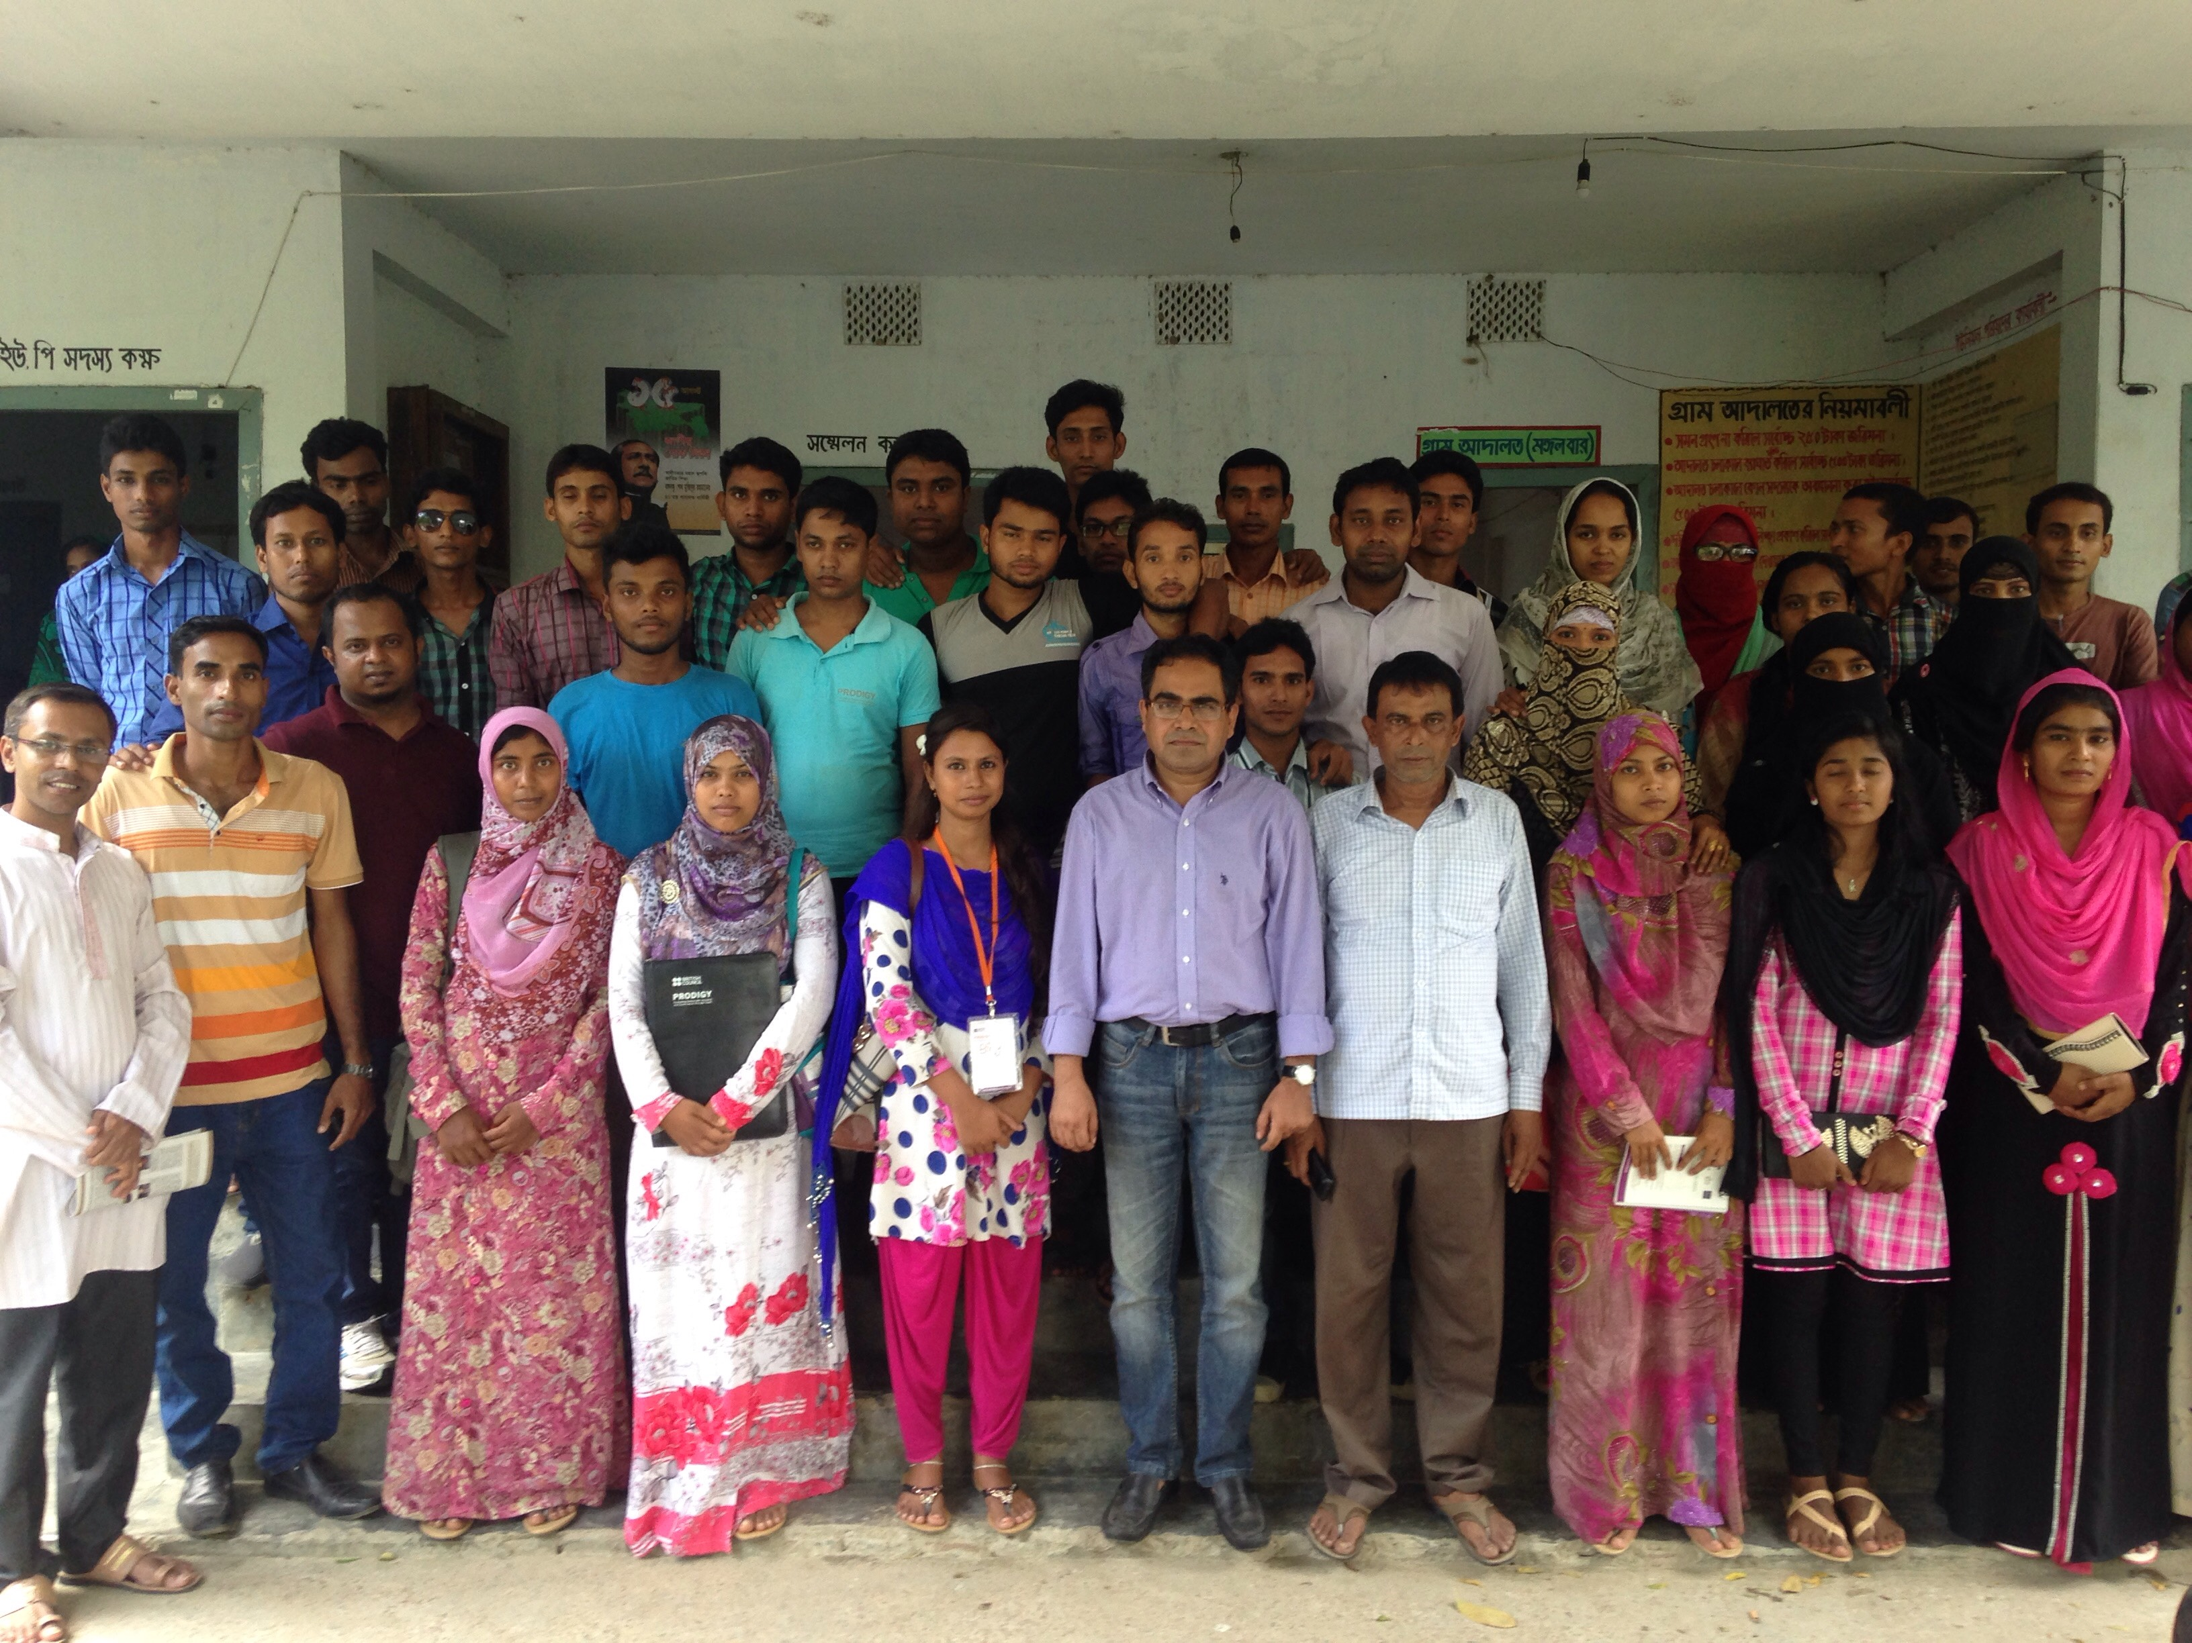
October 2016 || Dhaka

Kazi Maruful Islam, PhD
Department of Development Studies University of Dhaka
External Impact Evaluation of PRODIGY Project - Implemented by British Council, Bangladesh
External Impact Evaluation Final Report

External Impact Evaluation of PRODIGY Project Implemented by British Council, Bangladesh

Research Team
Principal Investigator
Kazi Maruful Islam, PhD
Professor, Department of Development Studies, University of Dhaka, Dhaka 1000; kazimaruf@gmial.com; kazi.maruf@du.ac.bd; Tel: +8801712 06 38 46
Co-investigator
Dr. AKM Saifullah
Independent Development Consultant; Dhaka; saifullah.akm@gmail.com

Associates
Mahmud Hasan
Kazi Rabiul Islam
Golam Mostofa
Abul Bashar
Mosiur Morshed
Sharmin Akhter Shakila
Jobaer Ahmed
Logistic and Management:
Shariful Islam Ratan
Coordination, Support and Supervision:
Toufiq Hasan, Acting Head of Society, British Council, Dhaka
Abdus Sabur, Project Manager, PRODIGY, British Council, Dhaka

© British Council, Dhaka, 2016
Contents
List of Acronyms i
List of Tables and Figures ii
Acknowledgement iii
Executive Summary iv
1. Introduction and Development Context 1
1.1. Introduction 1
1.1. Evaluation Objectives 1
1.3. Evaluation Methodology and Approach 1
2. Overview of the Project 5
4. Evaluation Findings 6
4.1 Relevance 6
4.2 Effectiveness 6
4.3 Inclusion 7
4.4 Innovation 7
4.5 Impact 7
4.6 Ownership and sustainability 8
5. Recommendations 9
6. Annexes (Primary Tables from Youth Data Set) 10

List of Acronyms

SAP | Social Action Project
NGO | Non Government Organization
UP | Union Parishad
THP | The Hunger Project
DW | DemocracyWatch
UNO | Upazila Nirbhahi (Executive) Officer
PNGO | Partner NGO
KII | Key Informants Information
FGD | Focus group Discussion
PRODIGY
USD | United States Dollar

List of Tables and Figures

Acknowledgement

Disclaimer
The views expressed in this report are those of the evaluators. They do not represent those of British Council or of any of the institutions referred to in the report.
Author
This report is written by Kazi Maruful Islam, with contributions from members and associates of his research team.

Executive Summary

1. Introduction and Development Context

1.1. Introduction
The report presents the evaluation of the project titled “Promoting Democratic Inclusion and Governance through Youth (PRODIGY)”. PRODIGY is a 21-months project ran from October 2013 to July 2015 with a total budget of USD 433,706.57 in which donor’s contribution was USD 297,000.
Promoting Democratic Inclusion and Governance through Youth (PRODIGY) is a British Council’s Society project designed by the Friends of British Council, implemented in 13 Unioon Parishads and 2 Pourashavas in seven districts across Bangladesh in partnership with five national civil society organizations: Uttaran, Shushilon, The Hunger Project, DemocracyWatch and Wave Foundation. As it is defined in the project document, the objective of the project is to increase peaceful civic participation in local governance in Bangladesh by empowering youth. The target population consisted of mainly youth; it, however, also includes local government officials and indirectly community in general.
The evaluation assignment was done under a contract awarded to the author of this report based on his individual capacity through a competitive process operated by British Council.

1.1. Evaluation Objectives
The objectives of the evaluation are to (a) assess the progress made towards each project goal of PRODIGY based on the current logic model, design and monitoring plan; and (b) determine the strengths (including successful innovations and practices) and weakness (factors impeding progress) of the programme planning, design, implementation and ongoing community engagement initiatives by PRODIGY youth leaders through Social Action Projects.
Having taken the broad two objectives into account, the evaluation assignment specifically explores answers of evaluation questions.

1.2. Evaluation Methodology and Approach
The evaluation was conducted by a team of national experts. In accordance with the agreed process, the evaluation aimed to answer questions across the criteria of relevance, inclusion, effectiveness, innovation, impact, and ownership and sustainability of the project. The evaluation questions are presented in the following table.

Table 1: Evaluation Questions
Evaluation Criteria | Evaluation Questions
Relevance | - What value did PRODIGY add to its context that community people are not aware of their rights or the services which they should be ideally be provided by the local government?
Inclusion | - How the programme involved and benefitted women, and other marginalised group (such as people with disability, ethnic or religious minority, extreme poor) throughout the planning, design and implementation of the project?
Effectiveness | - What extent the planned output (as per the project logic model) led to the achievements of the outcomes?  - Are there any differences at the achievement level between the grant awarded SAPs and the SAPs with no grant award?
Innovation | - How the Internship programme of PRODIGY project is benefitting the Interns as well as the local government offices?
Impact | - What percentage (%) of the targeted citizens in the targeted areas are motivated through PRODIGY interventions and actively participate in local governance, leading to increase civic participation?  - What percentage (%) of the targeted citizens, particularly women from poor and marginalised groups, in the targeted areas are aware of their rights?
Ownership and Sustainability | - How many young people and their networks in the targeted areas are inspired through PRODIGY interventions to take up similar initiatives

1.2.1. In conducting the evaluation of PRODIGY, a mixed research design based on Participatory Learning principles was followed. The participatory Learning Approach allowed the program participants – the youth – taking part actively in the evaluation activities.
Since the evaluation requires understanding and assessing the relevance, effectiveness, inclusion, innovation, impact and ownership and sustainability of the project, both qualitative and quantitative data are necessary to answer all the evaluation questions. Especially, the relevance, effectiveness, inclusion and innovation aspects are captured by qualitative data collection method while the impact has been captured and measured through quantitative survey. However, qualitative and quantitative data both have been used and analyzed to generate result of the evaluation.
1.2.2. Three main data collection methods: (a) a Rapid Knowledge and Practice (RKP) Survey, (b) Focus Group Discussion (FGD) and (c) Key Informants Interview (KII) were used to capture quantitative and qualitative data. In order to draw the findings of the evaluation triangulation was done between Survey, FGD and Interview data.
1.2.3. In order to understand the impact of the project, a Rapid Knowledge and Practice Survey was conducted among the target population in the selected union. This survey was rapid and brief. A brief and easily administrable Structured Questionnaire was developed and administered.
For the Survey, The sample respondents were drawn from among the target population in all 10 project localities in all five districts. Having considered the extent, scope and duration of the project interventions in the community, we argue that a widespread representative survey might not be appropriate to capture the project impact. Also, to mention, representative survey is time consuming and not cost effective either. Thus, we proposed a rapid survey among the target population only. With that said, a total of 100 sample respondent were surveyed. These 100 samples were distributed among all 10 project-locations; from among the target population of each of the project sites 10 (5 Male and 5 Female) respondents were randomly selected and interviewed with a structured questionnaire.
1.2.4. In order to assess relevance, effectiveness, inclusion and innovation aspects of the project the evaluation will mostly rely on the qualitative data. The qualitative data was collected using two methods: Focus Group Discussion (FGD) and Key Informants Interview (KII). From each of the project site two FGDs: one with the awarded social action project (SAP) stakeholders and one with non-awarded SAP stakeholders. In addition, 5 KIIs (2 youth, 1 UP/Pourashava leaders and 1 common citizen/opinion leader, 1 local civil society in the community) were undertaken. In all data collection gender and diversity was carefully maintained. Therefore, all together 20 FGDs and 50 KIIs were conducted from the field. For FGDs and KIIs open-ended checklist and interview schedule was developed and administered respectively.
Table 2: The number of respondents participated in the Evaluation
Data Collection Method | Number of Respondents | Nature of the respondents
Survey with Structured Questionnaire | 100 | Target population/Community members
Focus Group Discussions | 110 | Youth, program participants, community members
Key Informants Interview | 62 | Youth leaders, Interns, project management staffs and stakeholders
Survey with semi-structured questionnaire | 100 | PRODIGY training recipient youth
Total | 372 | Different categories of stakeholders
1.2.5. In addition to the field data, in order to understand the implementer’s perspective, a set of selected project stuff members, trainers and relevant persons from the partner organizations were interviewed to capture their opinion, experience and learning of the project. All together, 10 purposively selected persons from the implementing organizations were interviewed.
1.2.6. The Evaluation team also administered a semi-structured questionnaire among randomly selected 100 youth – PRODIGY training recipients – to measure the changes in their capacity, attitude and performance in relation to democratic governance at the local level. These data were used to assess the changes in the outcome of the project. Altogether, the team collected 100 structured questionnaires, 10 from each of the selected 10 project sites.
1.2.7. An extensive fieldwork was carried out during 8th August to 22nd August 2016 by the evaluation team consisted of 10 members including the Team Leader. The fieldwork took place in Tala, Magura, Dumuria, Khornia, Jahanabad, Mougachhi, Tetuljhora and Aminbazar Unions and Darsona and Chuadanga sadar wards in Darsona and Chidanga pourashavas. The distribution of the fieldwork locations is presented in the Table 3.
Table 3: Locations of Fieldwork
District | Upazila | Union/  Pourashava | Implementing PNGO
Satkhira | Tala | Tala sadar | Uttaran
Satkhira | Tala | Magura | Uttaran
Khulna | Dumuria | Dumuria sadar | Shushilon
Khulna | Dumuria | Khornia | Shushilon
Rajshahi | Mohanpur | Mougachhi | The Hunger Project
Rajshahi | Mohanpur | Jahanabad | The Hunger Project
Dhaka | Savar | Aminbazar | DemocracyWatch
Dhaka | Savar | Tetuljhora | DemocracyWatch
Chuadanga | Damuhuda | Darsona | Wave Foundation
 | Chuadanga sadar | Chuadanga | Wave Foundation

1.2.8. The evaluation team also reviewed relevant project documents namely Project Document, Monitoring reports, Grants Application, reports on SAPs sent by partners, baseline report, and newspapers clippings to build understanding and responding the evaluation questions.

1.3. Development Context
Despite the fact that in recent years Bangladesh has shown spectacular economic growth, she however, has failed to perform, by any standard, similar scores on the area of governance. As a result, the country has been labeled as a case of poor governance. One of the reasons of poor governance is that, common citizens particularly women and individuals from poor and marginalised groups, are not engaged with local public policy decisions that have a profound effect on their lives. The lack of civic participation in governance has led poor implementation of public policies and ineffective service delivery, especially at the local level.

Ever since independence, the Government of Bangladesh has made series of legislation to enhance civic participation, especially at the local level. For example, the Union Parishad Act 2009 has laid out the provisions like participatory annual budget preparation, participatory planning process, ward shava. These processes and provisions might produce increased participation if practiced. But mere existence of some provisions does not guarantee them to be functional. Observers noticed that lack of awareness among the common citizens, necessary skills, poor sense of ownership and the manipulation of the system by the local powerful actors are some reason among others which resulted in poor civic participation.

Bangladeshis need to actively engage in governance, both at the national and local level, and realise that civic participation goes beyond voting and elections. In fact, it is one of the most important factors in making communities function effectively and efficiently. And in an overpopulated country like Bangladesh, the need for efficient and effective services, whether provided by the government or by private sector, is essential to ensure the maximum utilization of the country’s limited resources.

Historically, youth have always been the drivers of social, economic and political changes in Bangladesh. Active youth civic participation was closely tied to the history of the struggle for national liberation in which young people played a major part. It is also acknowledged in the National Youth Policy. The British Council and its partners have observed, learned and identified, through projects like Active Citizens and the Youth Parliament, that even today, the understanding and recognition of the importance of civic engagement among young people is strong. Reports such as the Bangladesh: Next Generation and Giving Youth a Voice validate these findings. Thousands of young people are already engaged in various forms of volunteerism, including but not limited to planting trees, cleaning garbage, educating children from slums, raising awareness about child labor, and the dangers of drug addiction. However, their participation in governance is limited and seldom known beyond their local communities, and certainly not on a national scale. This project recognises the need to engage young people to promote and increase civic participation, empowering them to become agents of positive social change in their communities.

Geographically, the project will focus on areas including 15 Union Parishads (rural) and wards (urban) from all the 7 divisions (Dhaka, Chittagong, Sylhet, Khulna, Rajshahi, Barisal and Rangpur). These areas have weak local governance systems and minimal civic participation. In addition, the majority of the population in these areas are poor and marginalized and are often left out of the mainstream system of governance, without access to government facilities or services. Generally, they are simply unaware of both the services that are available to them and their rights as citizens. This is compounded by the fact that they are not confident in their ability to engage with government officials.

2. Overview of the Project

Working in 13 Union Parishad (UP) and 2 Pourashava since 2014, PRODIGY has developed the knowledge and skills of 540 young people to engage the wider community through volunteer activities, including youth club activities, theatre performances, internships with local government, community radio programs and public dialogues, creating platforms and channels to ensure that the wider community has access to government information. These 540 young people (aged 18 to 30, 50% female) have been given the skills to assess whether local government bodies are fulfilling their commitments and responding to citizens’ needs. Stressing the need for social inclusivity and equal participation, the focus in PRODIGY is on women, the poor and marginalized groups. These 540 young people of PRODIGY have been promoting civic participation in local governance and advocating the principles of integrity, accountability, transparency, inclusivity at the heart of good governance in its focus areas of 15 Union Parishad (rural) and Pourashava (urban) across 3 divisions (Dhaka, Khulna and Rajshahi) in Bangladesh. The three strands of PRODIGY are:
- Knowledge Development in Accountability, Transparency and Inclusivity
- Community Engagement
- Recognition and Demonstration of Positive Youth Engagement

3. Evaluation Findings

Promoting Democratic Inclusion and Governance through Youth (PRODIGY) is a British Council initiative. It was twenty one month’s long project aimed at promoting inclusion of the community in strengthening the lowest tier of rural local government bodies in Bangladesh, the Union Parishad. PRODIGY was simultaneously implemented in five different districts in Bangladesh and through five different local partners i.e. five different context and with culturally distinct areas. The following are the key findings of the evaluation exercise:

3.1 Relevance

Democratic inclusion is as important as anything given the country context in Bangladesh and as well in many other developing country setting. The people of Bangladesh love democracy and rarely got the opportunity to try and enjoy the same in real terms. As the project attempted to build an inclusive society and having a democratic local government institution, the community welcomed PRODIGY whole heartedly though there were differences in the level of greeting them. It was observed that this greeting to the democratic inclusion initiatives was usually differing according to the prevailing social and political culture and economic opportunities in the ground. In absence of a baseline however deter the team in comparing changes before and after the project intervention. Needless to say, the change whatever is made through project intervention is found to be well directed as people were found to be more interested about the UP activities that affect their fate in the ground which was not the case in general in other part of the country with no such project intervention. The survey data shows that 72% of the community people are engaged in social development activities one way or another. Of them 24% are engaged in rural justice system, i.e. Shalish, 11% engaged in managing school through School management committees, 41% engaged organizing sports and other events

3.2 Effectiveness

PRODIGY had been working on two grounds in the project locations- (i) capacity building of the youth and (ii) getting them engaged in initiating community development projects of their own with little or no financial support from administration. The capacity building regime successfully conducted all the training with target youth groups in the project intervention areas. During the field observation the team found that most of the your could remembers the names of the training they received from the project. On the whole the community got interested in the UP affairs in the PRODIGY intervention areas than before. They are more willing to participate in Yard meeting, Ward Meeting and any other meetings that they think might affect their interest. Moreover the youth in the community got the confidence that they had a stake in the community to get involved and they can evenly contribute to the community affairs like their guardians.

3.3 Inclusion

Inclusion is one of the key ingredients towards having better governance. PRODIGY project aimed at creating spaces for inclusion of the traditionally marginalized groups in the community who were by default neglected. The project targeted the women, persons with disabilities, religious and ethnic minorities etc. to involve more in the Union Parishad activities. And through project activities these disadvantaged groups at least started to think they belong to this society and they had a say to the issues that affect their life and livelihoods. Expecting too much from a short term project like PRODIGY is little ambitious, but it can be said that it was good beginning to work with in the long run.

3.4 Innovation

Getting the youth engaged in community activities is not a new thing in contemporary development interventions in Bangladesh. There were examples of youth involvement in community development activities and PRODIGY is another addition only. However PRODIGY brought forward a very innovative idea for the youth and for the Union Parishad as well. The introduction of INTERNSHIP at the Union Parishad for educated youth from the community was real innovation. This internship had a two pronged benefit in the project areas- (i) it helped the union parishad to get support from the community in the wake of human resource shortage at their disposal; and (ii) a young people in the community also get firsthand experience of official work and get into development affairs of the community as well.
Mita Raha, of Dumuria UP Khulna: She is an inhabitant of the UP and also a third year (hons.) student. She expressed her satisfaction of the opportunity to work as an intern to the UP as … I had no idea how UP work and never tried to. But with UPs I had to assist them in issuing Birth and Death certificates, inheritance certificate, keeping records which was new world to me. I have seen the people are more comfortable with me and the fear factor among the common people among UPs was slowly faded away. I had also attended meeting at Upazila and District level which had given me the opportunity to meet the government officials and learned many things from them as well. UP council also appreciated my work as I had contributed to lessen their workload.

3.5 Impact

Leaving development impact is one of the goals that any development endeavors and PRODIGY project is no exception either. In this project the big impact expected was to leave the legacy of the youth community get involved in the UP activities on the one hand and getting the disadvantaged groups to be mainstreamed on the other. The project interventions facilitated the community to get involved in UP activities such as different meetings. The survey data revealed that 43% of the respondent participated in Ward Meetings, 29% attended open budget meeting, 9% participated in Standing Committee activities, 8% other development activities of the UPs, and 6% availed services from Village Court. 7% participated in women and children related activities. It was also observed that 99% of the respondent at least once attended in either Ward Meeting or Open budget meeting, which was encouraging scenario in the country context, for the project. The youth initiated social action projects got acclaimed by both the community and the UP. Replying to other questions 91% were willing to participate in youth led activities in future and 92% were willing to participate in community development activities. However this was just a beginning and it needed to be continued for several more rounds to get the community acquainted with the tasks and the UPs to get used to welcome the community to UP affairs which had never been the case in Bangladesh.
A common citizen during interview expressed his satisfaction of the youth initiatives and requested this continue for a longer period. According to him this youth are the future of our country and they should have trained well for undertaking community development activities.

3.6 Ownership and Sustainability

Ownership and Sustainability are the issues that are challenges of any development intervention to leave behind. The main issue of ownership was the social action projects (SAPs). These SAPs were conceptualized, designed and implemented by the youth groups were trained and technical assistance provided by the PRODIGY project. During the project designing phase the youth got to learn the social problems and the ways to overcome these problems for the betterment of the communities they belong to. There was enthusiasm among the youth and if this can be ingrained among the youth they would certainly own what they conceptualized. If this goes on a process of involving new youths in the similar activities would be in place, as promised by the youth during field intervention. Again recruiting new youths and evolving the process automatically would eventually make it sustainable in the long run. However it is too early to expect the same from a two-year intervention.

4. Recommendations

1. Having the considered the potential of the project in bringing changes at the grassroots the team recommend the project to continue for few more years. However, it may consider several modifications on the following aspects:

- The recruitment of the youth should be based on a set of well crafted principles
- The selection of project location should be based on the interest of the concern UP for ensuring all-out support and commitment of the respective communities. For example, for the case of Saver, it was found that the community and the UP has different priorities
- The design of the SAPs needs to be scrutinized following a set of transparent criteria which must include priority of the community
- For sustaining the initiatives taken under SAPs, community engagement is a prerequisite
2. Since the Internship with Union Parishad has been found as the creative innovation of the project, the evaluation team, thus, recommends it to continue for a longer period.

3. The evaluation found that the link between youth and the adults of the society is weak, thus the team recommends working out an effective measures to build strong linkage between the youth and the adults in the community.

6. Annexes (Primary Tables from Youth Data Set)

Table 1: Youth participated in PRODIGY activities (N=100)

Table 2: Names of the training as mentioned by the youth leaders (N=100)

Table 3: What according to the youth important is for getting engaged in LG activities (youth only)

Table 4: Major social hindrances in conducting community work as PRODIGY attempted to promote (youth only)

Table 5: Whether participation of community increased through PRODIGY intervention (youth only)

Table 6. Whether participation of community increased through PRODIGY intervention (youth participants only)

Table 7: Youth leaders’ perception of community participation increased in UP activities due to PRODIGY intervention (youth only)

Table 8: Participation of Women, Persons with Disability, Religious and ethnic minority increased due to PRODIGY intervention (youth only)

Table 9: My leadership skill increased after receiving leadership training from PRODIGY (youth only)

Table 10: My knowledge on transparency, accountability and active citizenship increased through PRODIGY training (youth only)

Table 11: My knowledge on financial management and its importance increased through PRODIGY training (youth only)

Table 12: Willingness to be engaged in similar work in absence of a project like PRODIGY (youth only)

For an unknown population with no specific demographic parameter, using $n=Z^{2}*pq/d^{2}$ at 95% of level of confidence with 10% margin of error, 100 is a reasonably valid size of sample.

